1613 Cutter Overload Test Comparison
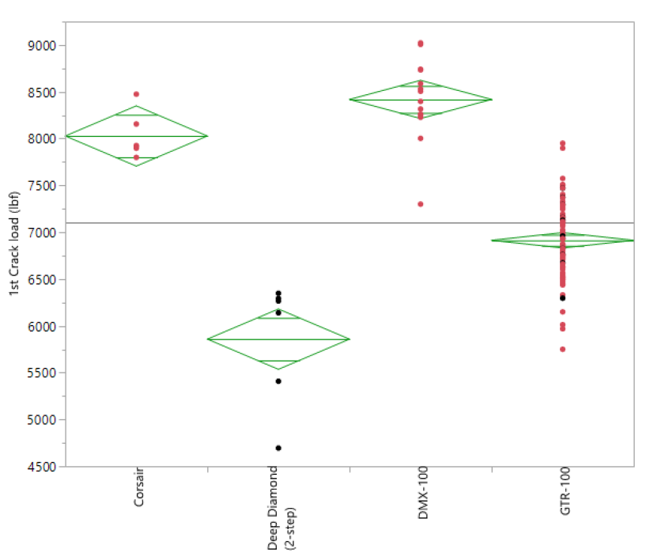

Cutter C
Cutter B
Overload
Cutter
Cutter D

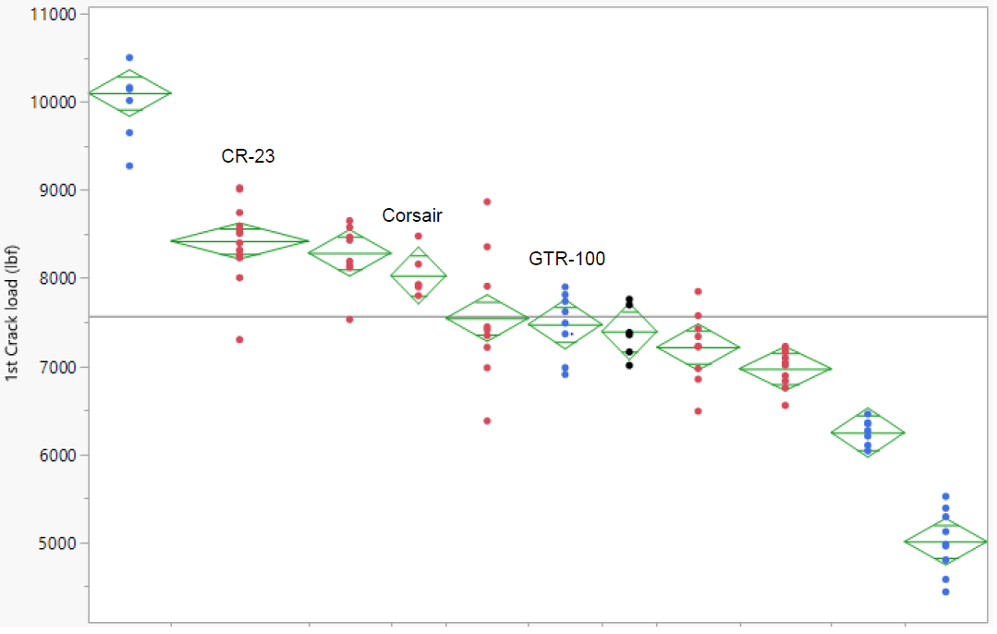

Overload Cutter
Data Points

